Leetcode_76_MinimumWindowSubstring_最小窗口子串_Hard

# Leetcode_76_MinimumWindowSubstring_最小窗口子串_Hard

## 题目描述

* 难度：Hard

* https://leetcode.com/problems/minimum-window-substring/description/

* Given a string S and a string T, find the minimum window in S

* which will contain all the characters in T in complexity O(n).

* Example:

* Input: S = "ADOBECODEBANC", T = "ABC"

* Output: "BANC"

**\* Note:**

* If there is no such window in S that covers all characters in T,return the empty string "".

* If there is such window, you are guaranteed that there will always be only one unique minimum window in S.

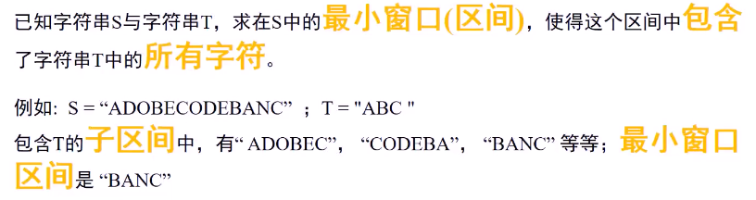

## 思路分析

* 思路分析：双int[]字符哈希表和双指针最小窗口。需要两个int[]对S和T进行字符次数统计。

*首先统计T字符串的字符数目；然后利用双指针构造滑动窗口；

*right右移一个字符，首先hashMap_S对该字符数目加1，然后

*尽可能地移动left：通过while实现，移动条件有两个：hashMap_T中不存在left字符或者hashMap_S中该字符数目大于hashMap_T；

*然后再判断当前窗口是否满足要求且是否比上次更短，若是，则更新，否则continue。

## Java代码

public String **minWindow**(String s, String t) {

if(s == null||t==null||s.length()==0||t.length() == 0||s.length() < t.length()) return "";

int[] hashMap_T = new int[128];

int[] hashMap_S = new int[128];

char[] chars_t = t.toCharArray();

for(char c:chars_t) hashMap_T[c]++;//对T字符串进行hash统计计算

char[] chars_s = s.toCharArray();

int left = 0,right = 0;//双指针，表示窗口的左和右端点

int windowLen = chars_s.length;

String result = "";

for(;right < chars_s.length;right++){//遍历S

hashMap_S[chars_s[right]]++;

//尽可能让left向右移动

//两种情况移动：left字符不在T中和left字符出现次数大于T中该字符次数

while((left < right) && (hashMap_T[chars_s[left]] == 0|| hashMap_S[chars_s[left]]>hashMap_T[chars_s[left]])){

hashMap_S[chars_s[left]]--;

left++;

}

int currentLen = right-left+1;

if(currentLen < chars_t.length) continue;

if(windowLen >= currentLen && doesScoversT(hashMap_S,hashMap_T)){//一定包括等号，因为若S与T相等情况

windowLen = currentLen;

result = new String(chars_s,left,right-left+1);//保存

}

}

return result;

}

/**

* 判断此时窗口是否已经包含T的所有字符

*/

public boolean **doesScoversT**(int[] hashMap_S,int[] hashMap_T){

for(int key = 0;key < hashMap_T.length;key++)

if(hashMap_T[key] > hashMap_S[key])

return false;

return true;

}

